

Hotel Booking System

REPORT SUBTITLE

Name | Course Title | Date

# External Library

I didn’t used any external library as there was no need to use one. But if this was GUI based than i would have used JTattoo for interface because its time saving and very efficient with fantastic look and feel.

# Description

Its very simple project and easily understandable even by new developers. There are two source packages namely *BookingSystem* and *ui*. All .java files are in src folder and .class files(compiled classes) are in bin folder.

Common or general structure is as follows:

src - contains all source files, and possibly the following as well (might be far down the folder tree):

* + resources - contains resources such as properties files
  + config - everything config related
* lib - a folder containing a your libraries, possibly placed in separate subfolderrs
* bin - contains compiled classes

ui package has main class namely UI class which contains menu for interacting with user and main method.

UI class instantiates Hotel class and inside Hotel Ticket is instantiated.

# Method/Material

I used NetBeans IDE for my project. On some points I got stuck but I tried my best to find solution and with the help of documentation on Oracle site I was able to tackle many problems. Oracle documentation is a rich source of information for new as well as experienced developers. I also referred to “Java How to Program by Paul Dietel”.

# Project Implementation

I didn’t created any pseudo code or class diagrams before implementation. I just read the requirements specification and started coding. Pics of output are attached but you can try to play with the output for detailed info of project.

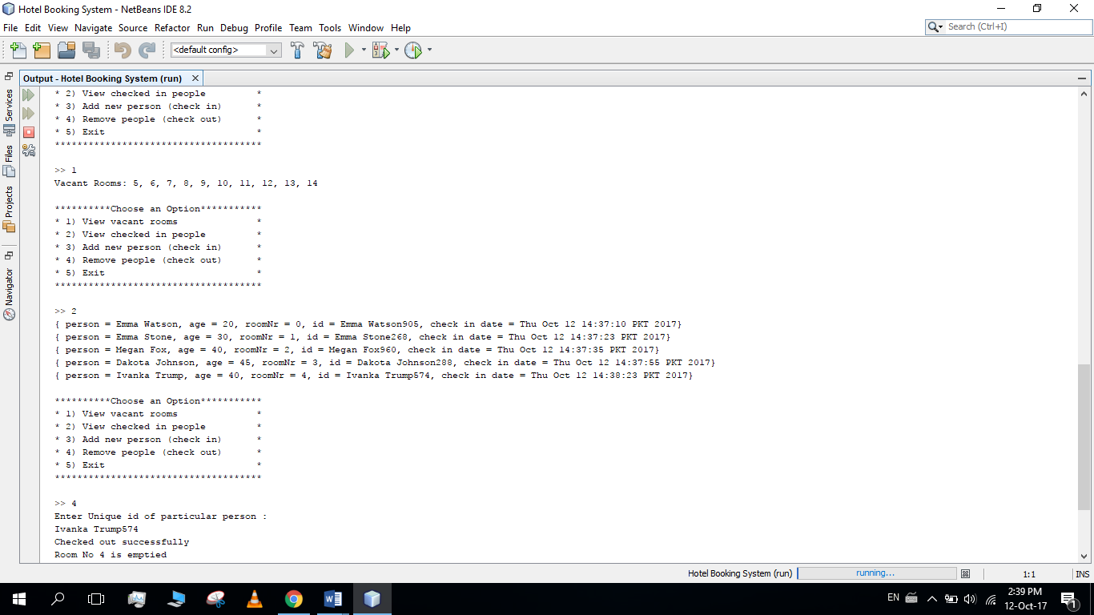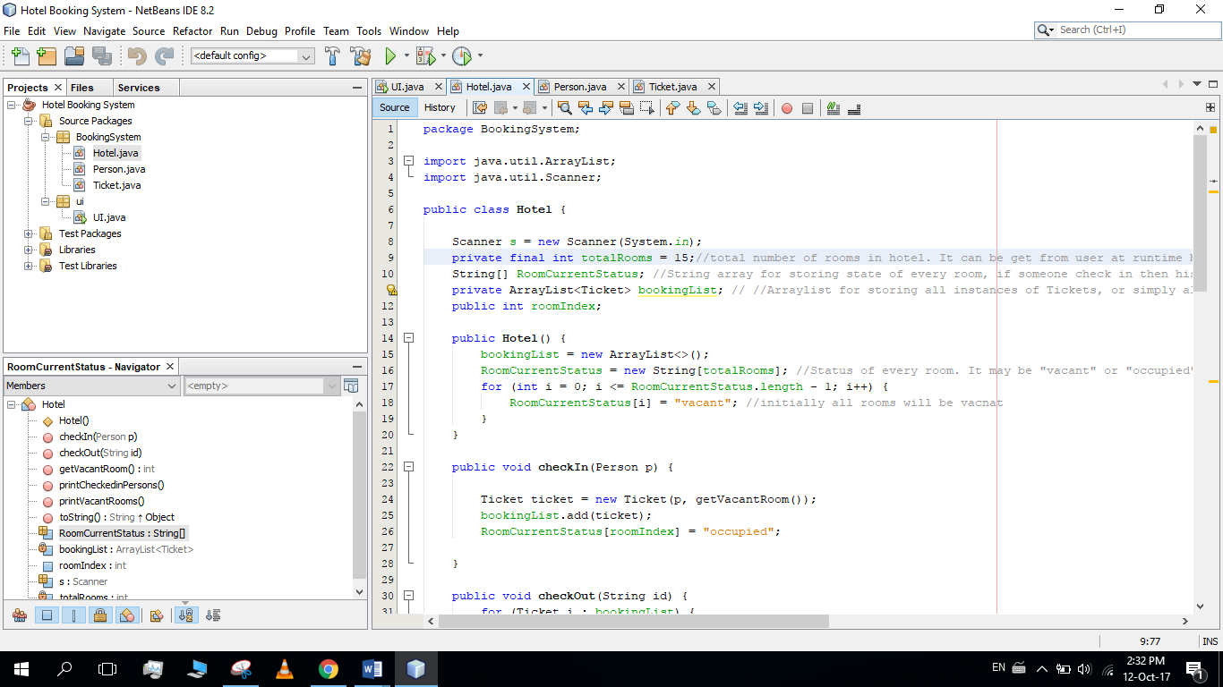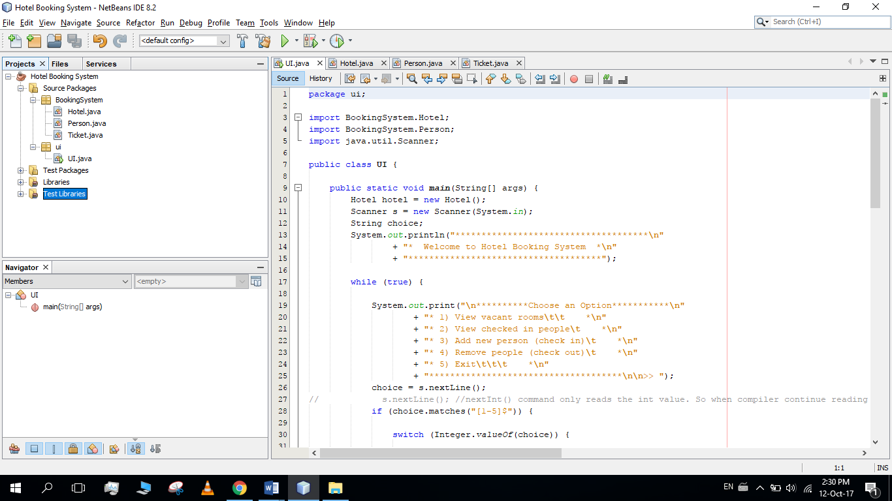

<End/>